Installation Guide

# Xampp/Web server

1. Download or use the installer for XAMPP and install in drive C: or any other drive.
2. After installing xampp, find the application and right click then run as administrator.
3. Refer to image 1 below, Click on PHP (php.ini)

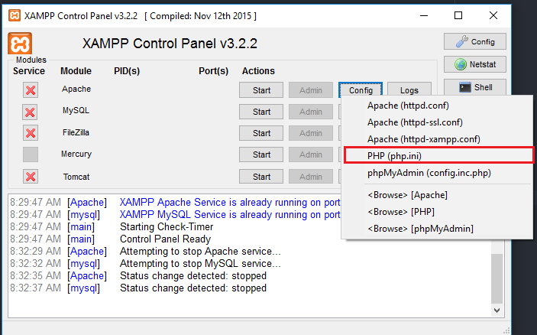

Image 1

1. Refer to image 2, Upon opening PHP(php.ini), find “post_max_size” and change whatever value to the value of 1000M (1Gb) which is the maximum size that is set in the website.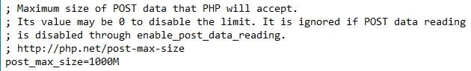

Image 2

1. Refer to image 3, Next, Look for “upload_max_filesize” and change whatever value to the value of 1000M (1 Gb) and look for “max_file_uploads” and change whatever value to the value of 1000.

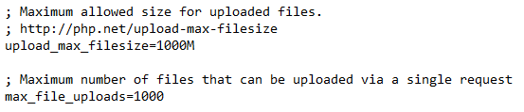

Image 3

1. Refer to image 4, Nex, Look for “max_execution_time” and change whatever value to the value of 0, which means that the execution time for the website will be unlimited. This is for 1gb file uploads. After this save and close the notepad file.

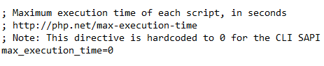

Image 4

1. Refer to image 5, Click the two buttons in the red box. Each click would need administrator rights since this will install the Web server and the Database server as a windows service.

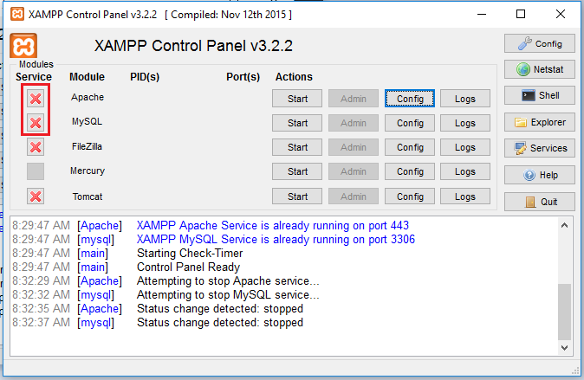

Image 5

1. After installing the two as a service, restart the computer and proceed to next step.

# Installing the website on the server and installing node.js

1. Normally, the link to the root directory of the server would be “C:\xampp\htdocs” but the drive letter may change. Go to this folder and paste the “AbivaHR” website here. Refer to the highlighted part of the image below (Image 6) folder contents may vary.

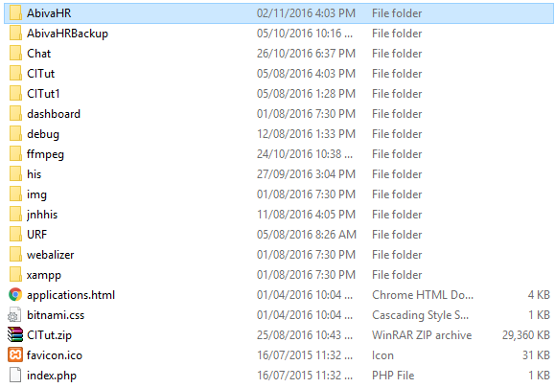

Image 6

1. Download Node.js from the internet or use the installer provided. After installing, open the “AbivaHR” folder, “Shift + right click” anywhere and choose “Open command window here”. Re fer to image 7.

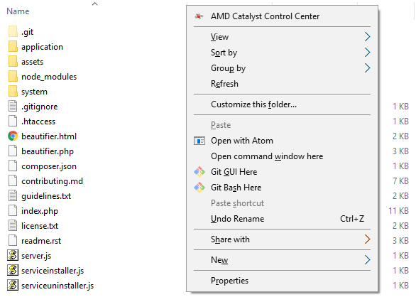

Image 7

The following set of instructions (3 – 5) is to be followed step by step, should step 3 fail on the first try, restart computer first then try gain.

STEPS 3 – 5 IS OPTIONAL FOR AUTOMATICALLY STARTING CHAT SERVICE, IF STEPS 3-5 IS SKIPPED, PROCEDE TO STEP 8.

1. When the command prompt window opens, type “npm install -g node-windows” a series of prompts may appear, just click yes if there is.

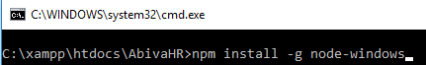

1. After that, still in the same command prompt, type “npm link node-windows”

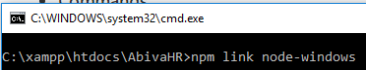

1. After that, still in the same command prompt, type “node serviceinstaller” or “node serviceinstaller.js”. running this command will result in a series of prompt boxes. Click yes for any prompt. If you installed xampp on drive C. If xampp is installed on another drive, go to the root folder of AbivaHR, open “Serviceinstaller.js” in any editing program and change the drive letter there.

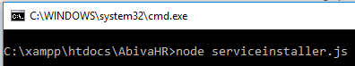

1. What step 5 does is install the chat server of the website as a service in the computer. After steps 3-5, go to windows services. (Search in windows)

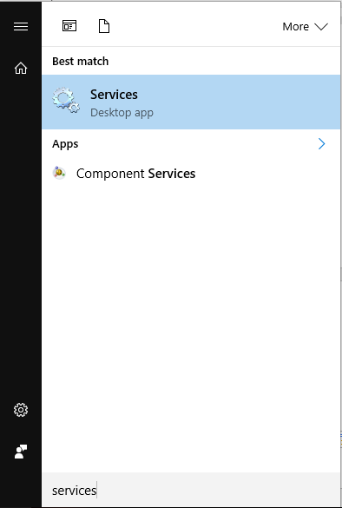

1. Look for AbivaHR Services. Normally, the service would run automatically, just like in the following picture, but if the service status is not indicated as “running” right click the service and press start

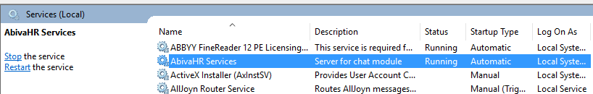

1. If steps 3-7 is skipped, to open the chat module, “Shift + right click” anywhere in the folder and choose “Open command window here” then type “node server.js” then “Server listening at port 3000” should appear

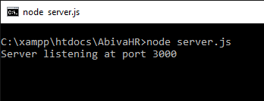

8.

# Database file

1. Next step would be importing the database. Open google chrome and type in the url “localhost/phpmyadmin”. Upon opening, click on the “Databases” tab and type in “AbivaHR” in the text box.

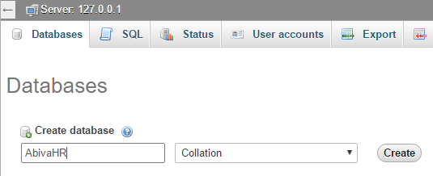

1. Refresh the page, and “abivahr” should appear in the left sidebar. Click it and when the page loads, press “import” located at the top tabs. Choose the file that came with the AbivaHR and press go at the very bottom of the page.

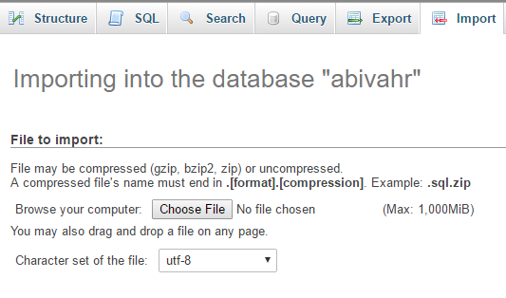

1. That is the last step, you may now go to “localhost/AbivaHR” and use the website. But the website would only be available on the computer. Continue on to the next steps to make the Web server available to everyone in the Local Area network.

# Website configuration

1. Open and explorer window and type this in the url “C:\xampp\htdocs\AbivaHR\application\config” or just open the folder. Drive may change. Upon opening the folder, locate “config.php” file and open in any editing program. Change “$config[‘base_url’] = ‘http://localhost/AbivaHR” to “$config[‘base_url’] = ‘http://192.168.*.*/AbivaHR”. Where 192.168.*.* is your computer ip address.

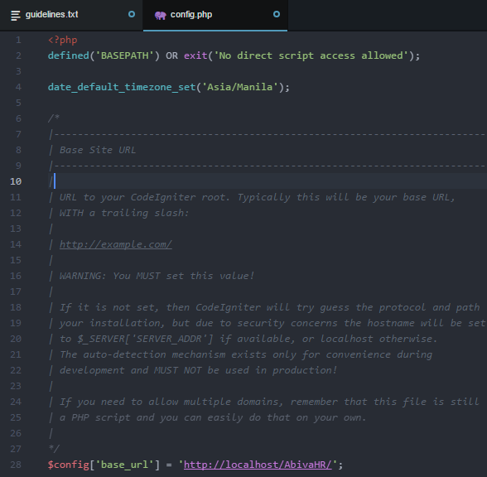

1. Next would be adding exception in the firewall for people to be able to access your http server.

Open windows firewall advanced security. On the left sidebar, double click “inbound rules” and look at the right sidebar, the click “New rule…” on the following prompts, follow the following images.

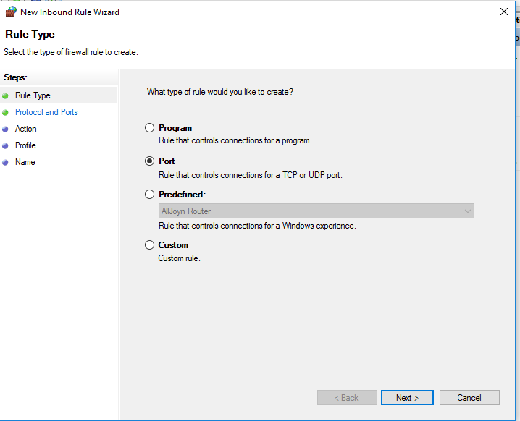

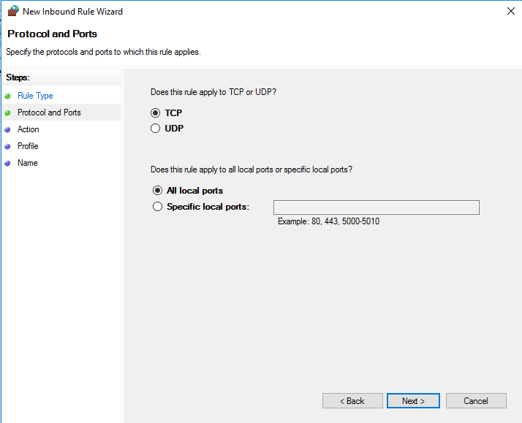

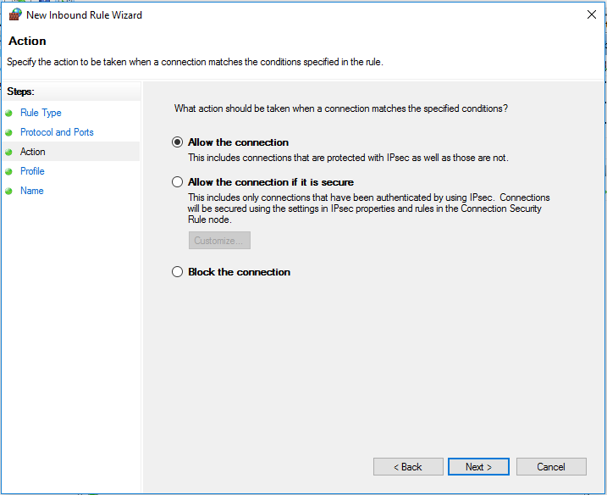

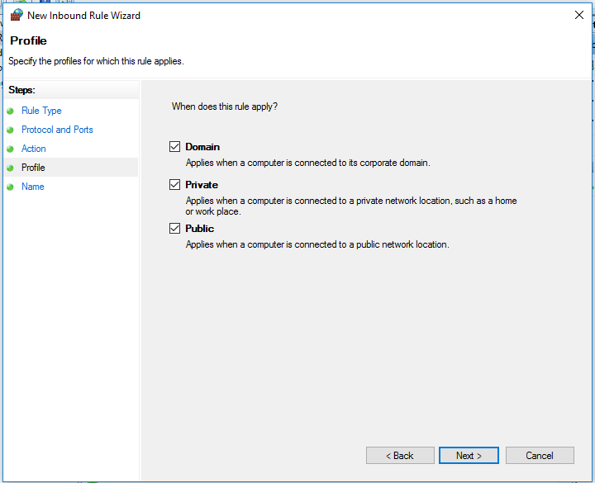

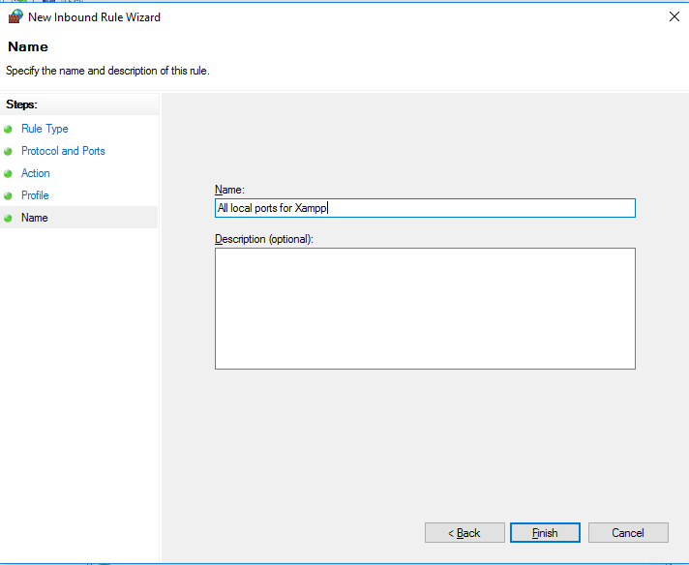

After that, restart the computer, and access the website through and computer using “192.168.*.*/AbivaHR”